14/12/2023

Chakradhar Bhogapurapu, BIBA

Python

🡪Nested for loop

For loop in a for loop is known as nested for loop.

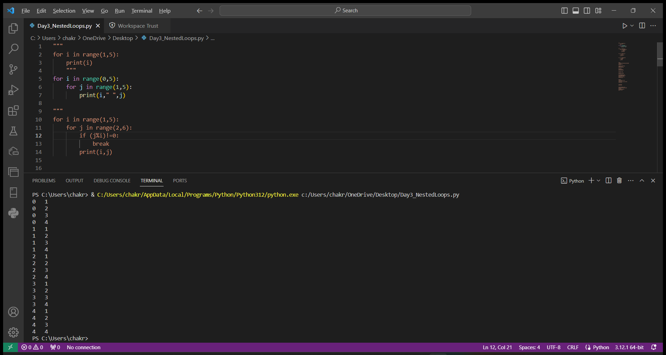

🡪break

Break statement is used to stop the execution of loop

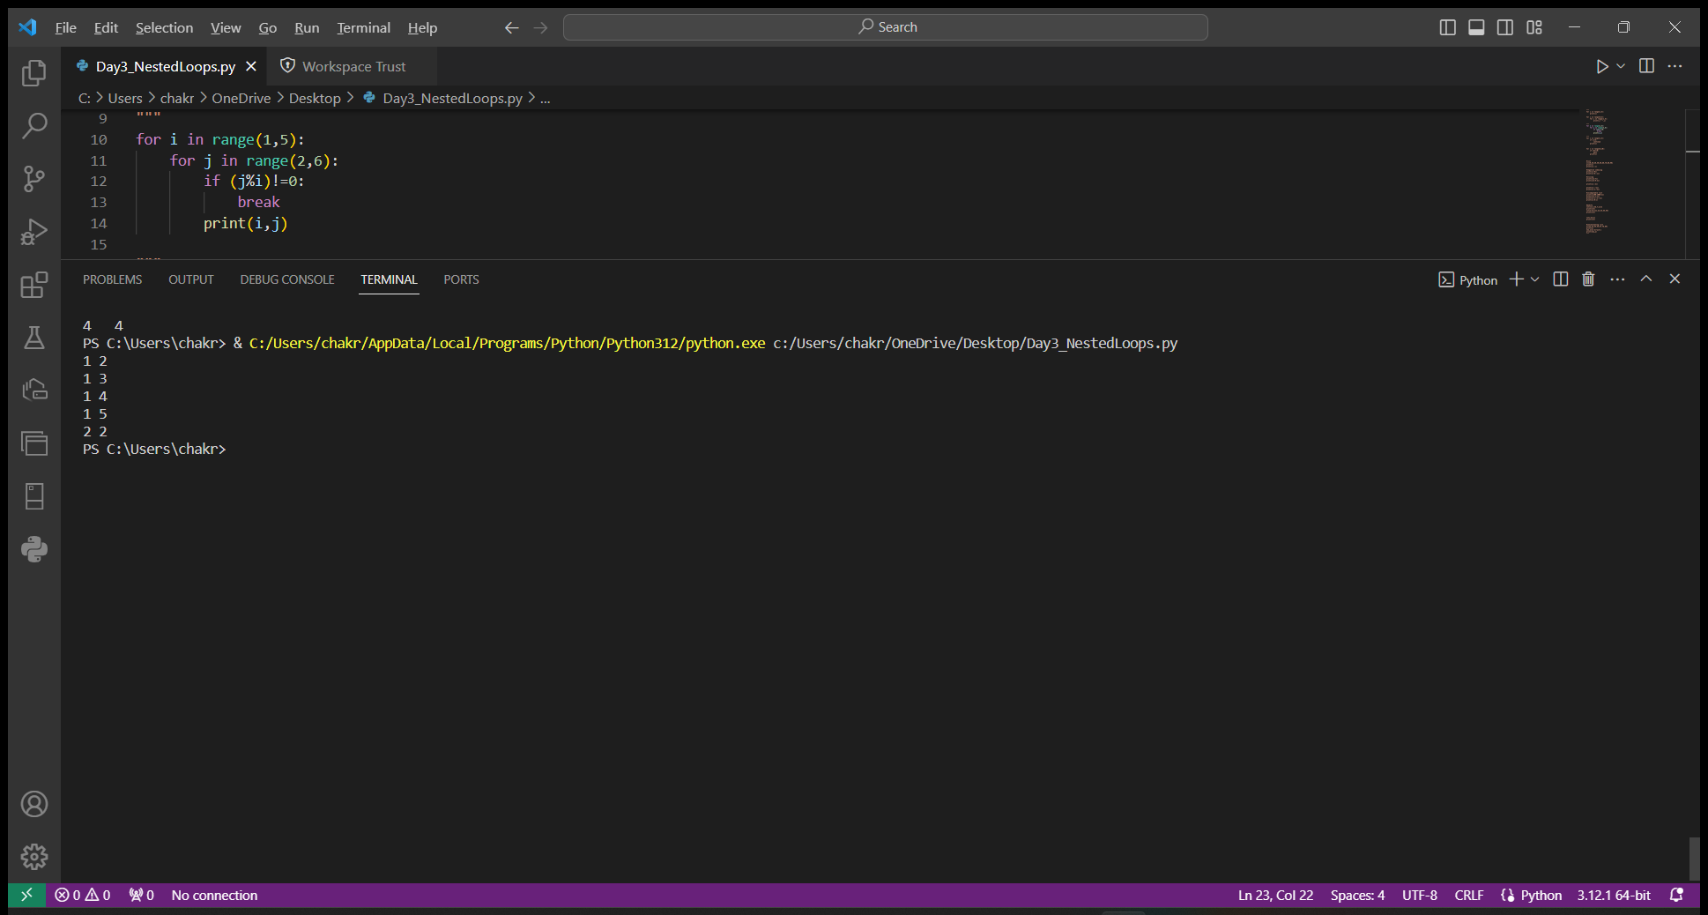

🡪Continue

The continue keyword is used to end the current iteration in a loop and continues to the next iteration.

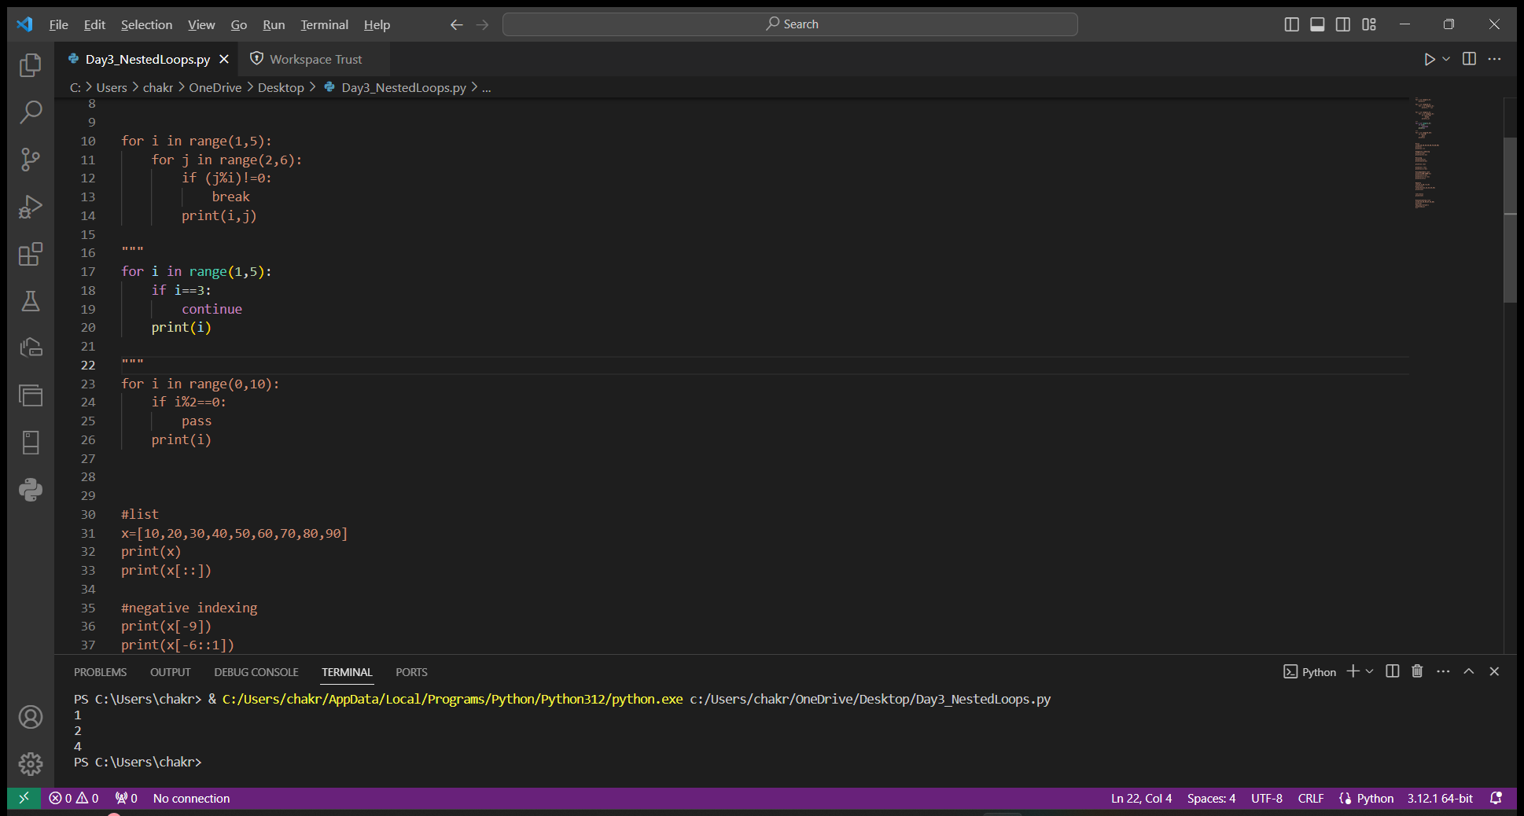

🡪Pass

When the pass statement is executed, nothing happens, but to avoid getting an error when empty code is not allowed.

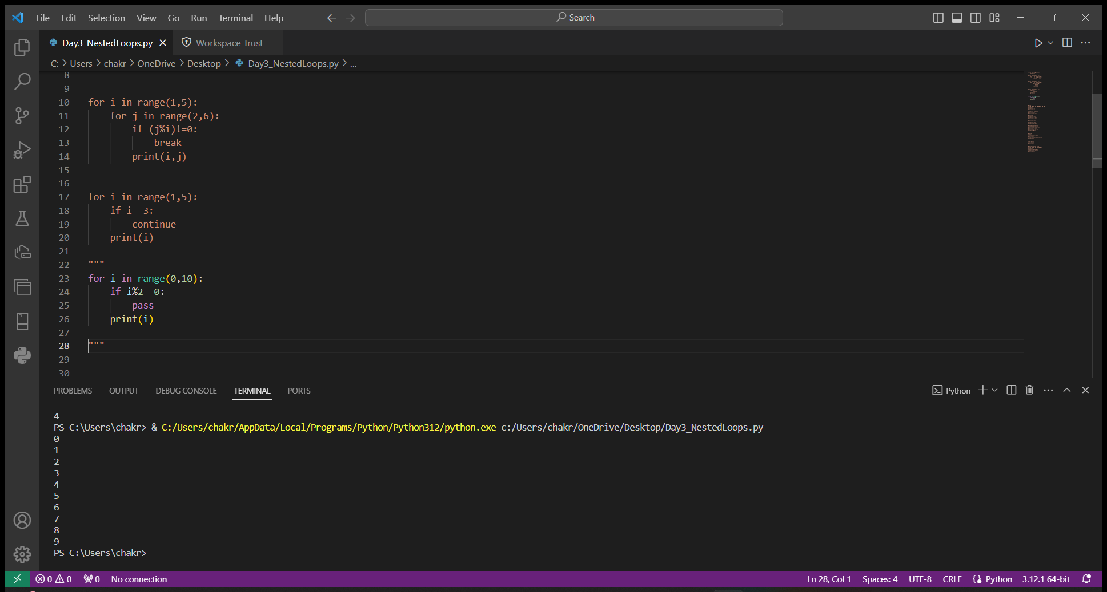

🡪List

List is used to store multiple values with different data types in a single variable. List is indicated with square brackets [ ].

Syntax: list_name[start : end-1 : step]

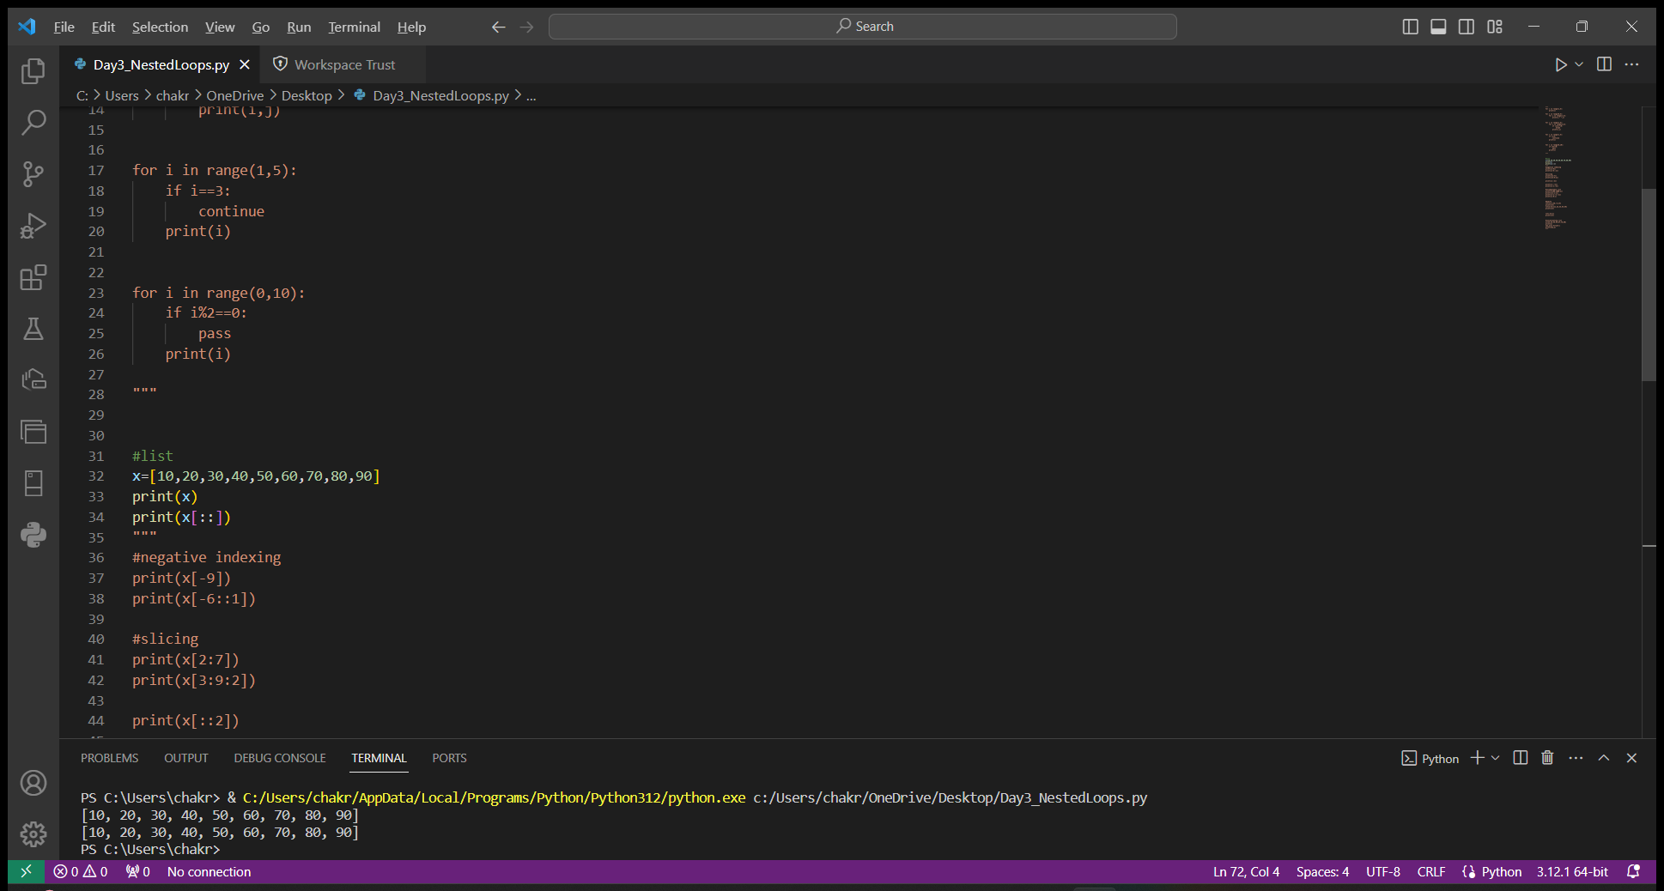

🡪Negative indexing

List indexing starts with 0. To index the list from last, they are indicated with negative numbers starting with -1.

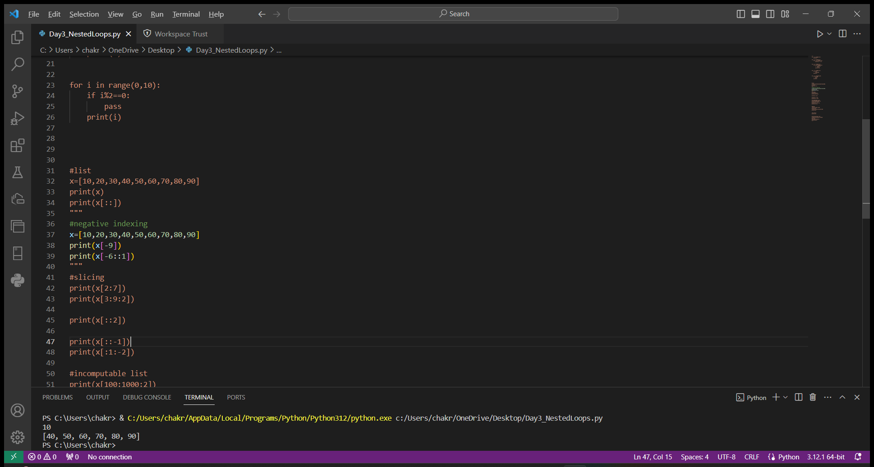

🡪Slicing

Slicing is a concept in list, in which we can get the sub list from the actual list by slicing it.

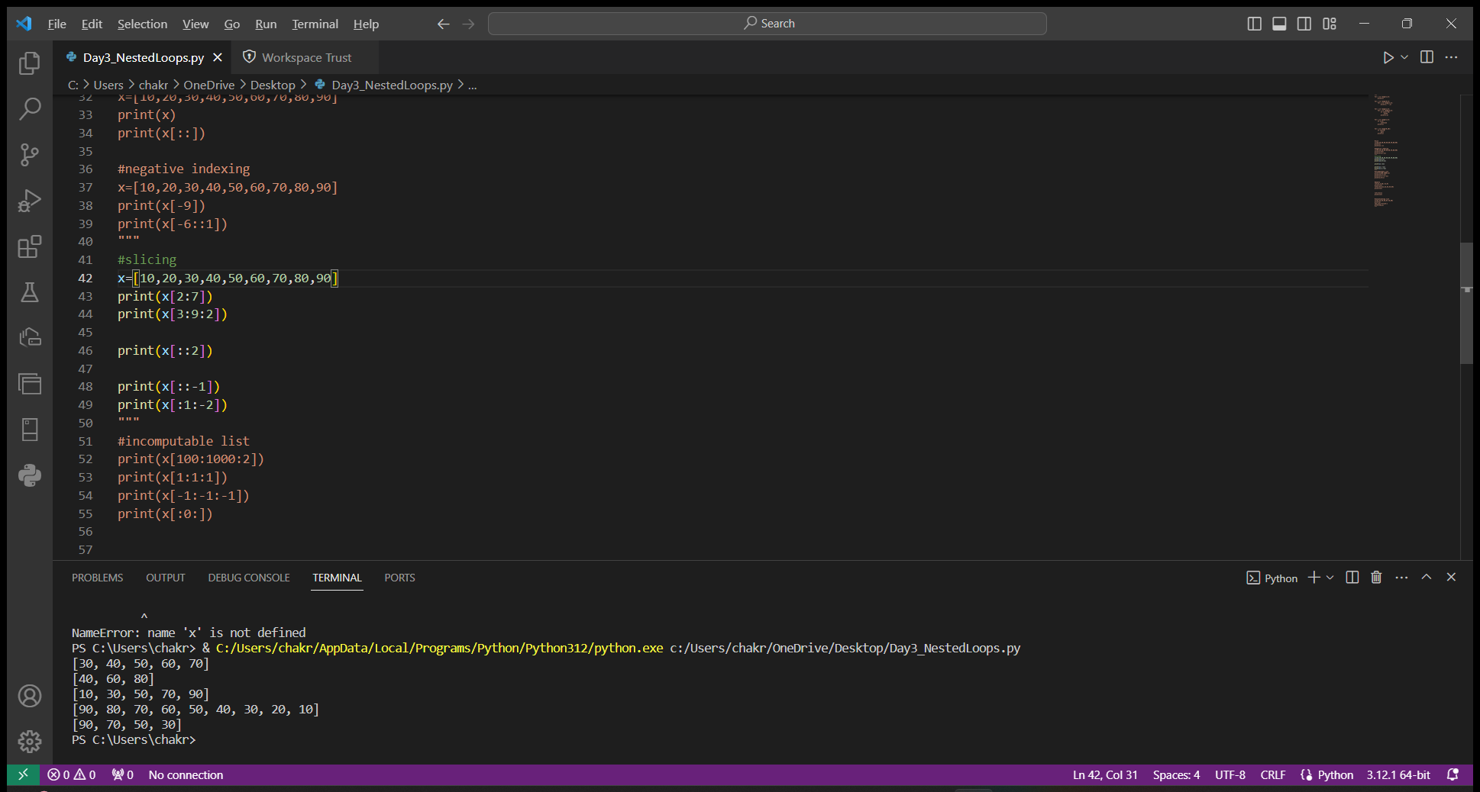

🡪Incomputable list

In the below example, we are trying to access the list without looking into the list limits. In this we get empty list as output.

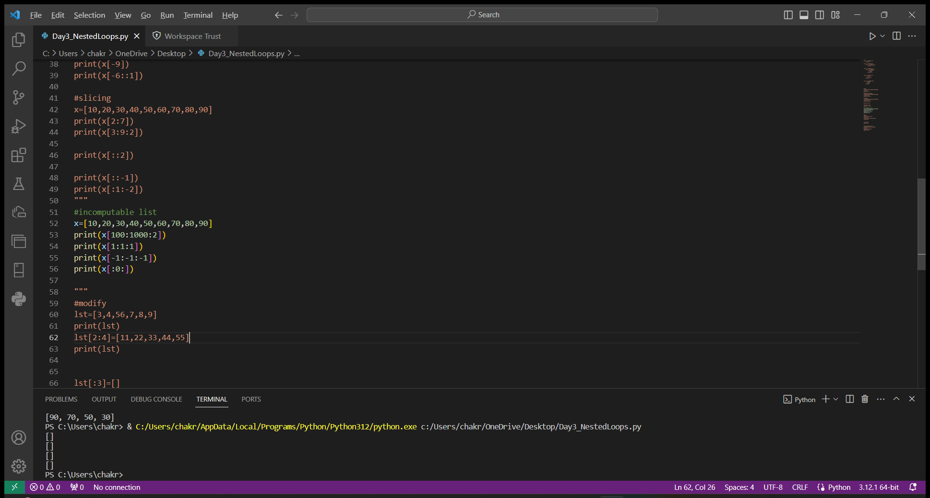

🡪Modify

We can modify list with the help of index of the list. We can simply update the values at the desired index of the list.

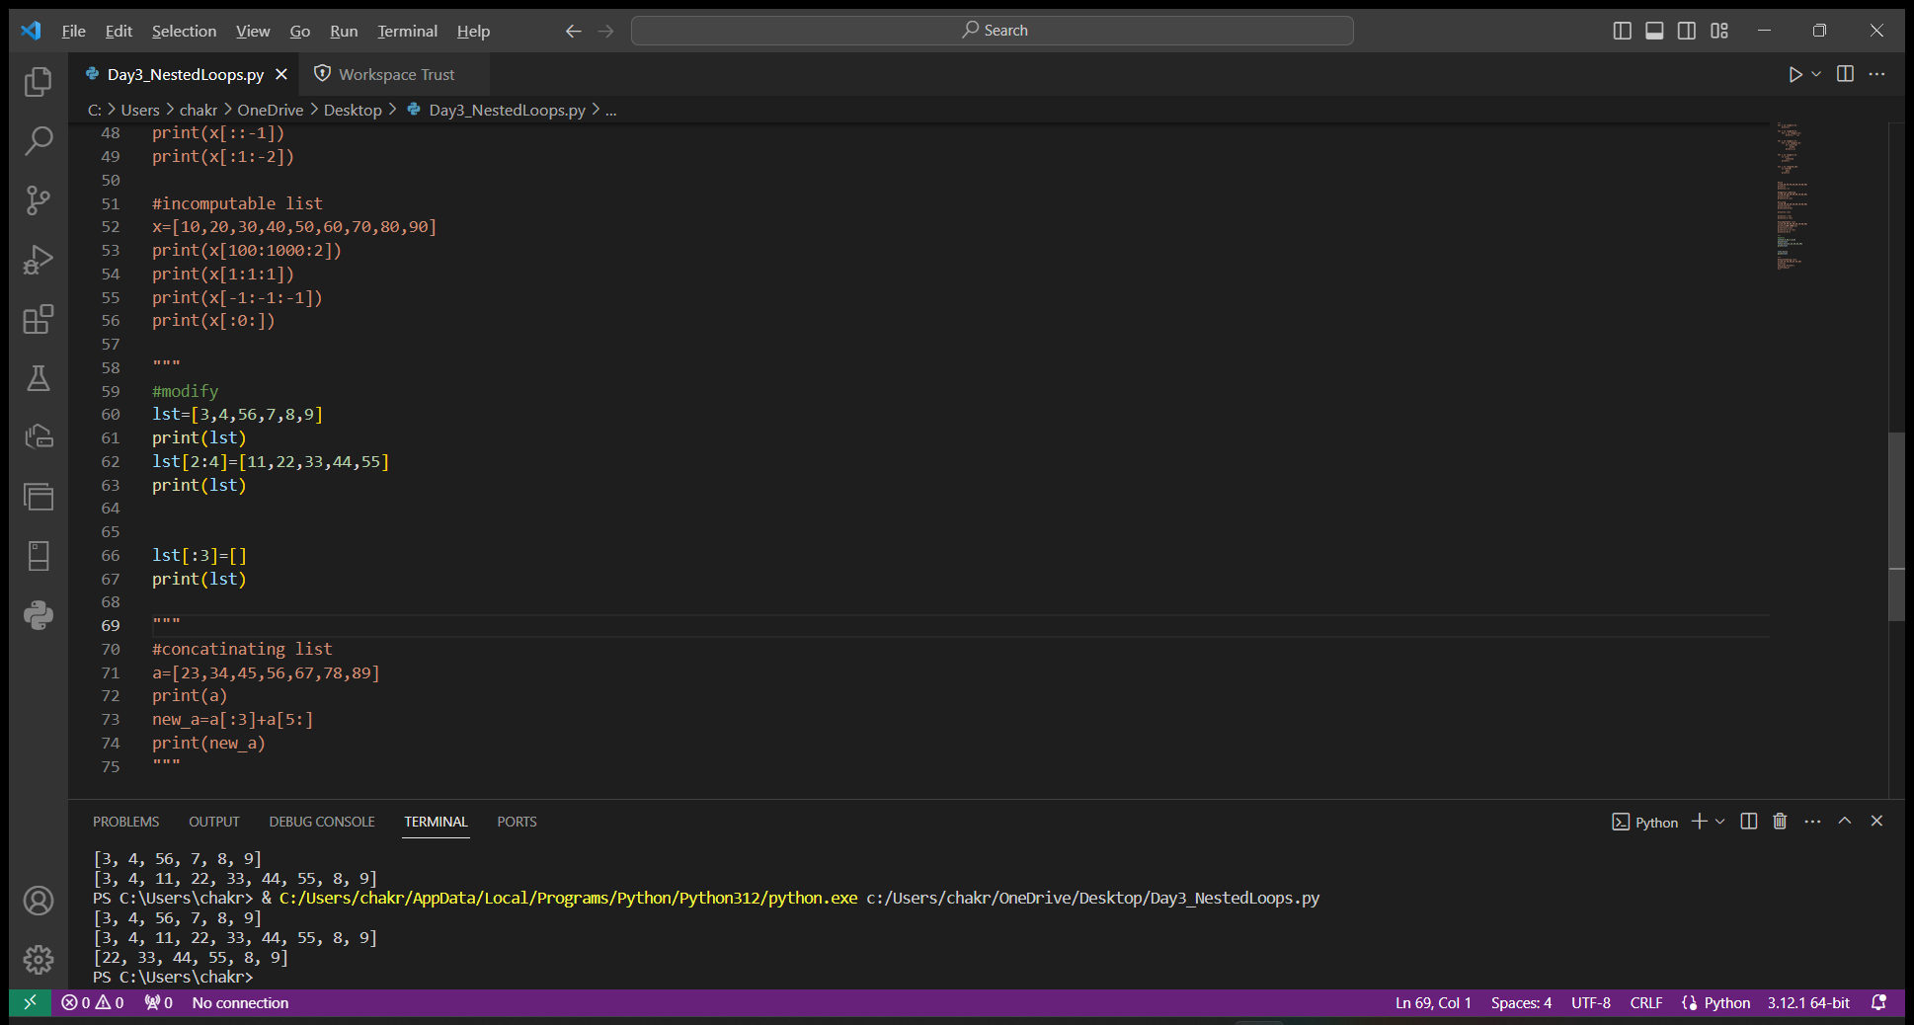

🡪Concatinating lists

We can create a new list by merging to different lists or we can also create new list by merging parts of the same list.

